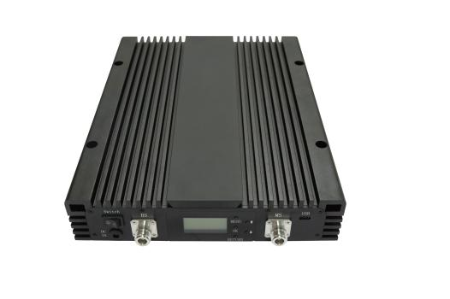
500mW 700+1800+2100MHz Repeater
Model: AT012-L7DW-27

Product Features:
- Improve any three mobile networks at the same time
- LCD display the input/output signal strength
- Auto isolation detect function
- Auto gain control ,auto level control
- Auto uplink noise reduction,avoid disturbing to BTS
- Smart LCD to guide the installation
- Metal industrial design

Working Schematic Diagram
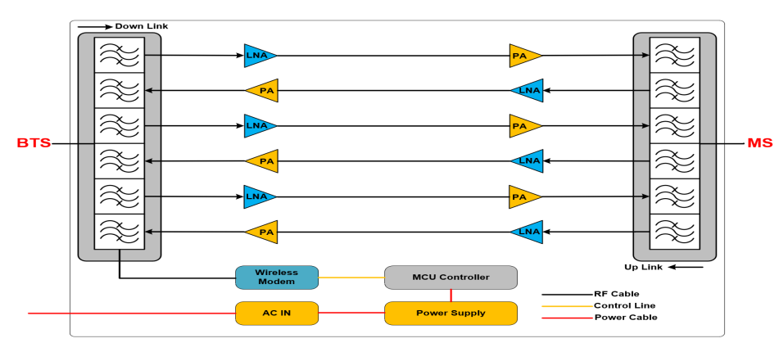

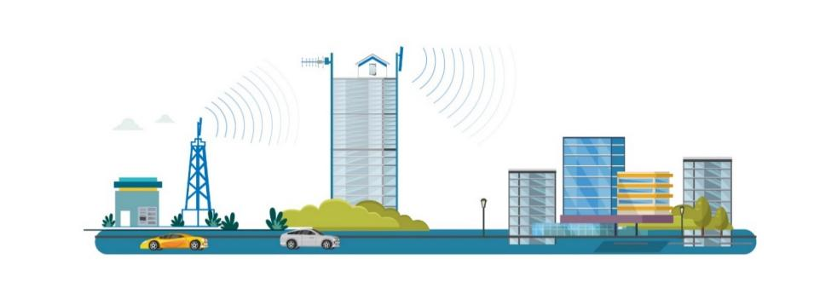
Application Scenario:

Technical Specifications:
P/N: AT012-L7DW-27 |  | B3 (1800MHz) | B1 (2100MHz) | B28(700MHz)
Frequency Range | Uplink | 1710-1785MHz | 1920-1980MHz | 703-748MHz
Frequency Range | Downlink | 1805-1880MHz | 2110-2170MHz | 758-803MHz
Bandwidth |  | 75MHz | 75MHz | 35MHz
Max. Gain | Uplink | 75±3 dB | 75±3 dB | 75±3 dB
Max. Gain | Downlink | 85±3 dB | 85±3 dB | 85±3 dB
Manual Gain Control |  | 31 dB in step of 1 dB
Automatic Gain Control |  | ≧ 20 dB
Gain Flatness (per sub-band) |  | ≦ ±3 dB (peak-to-peak) |  | ≦ ±3 dB (peak-to-peak)
Max. Input Power Without Damage |  | 0 dBm
Output Power | Uplink | 20±2 dBm | 20±2 dBm | 20±2 dBm
Output Power | Downlink | 27±2 dBm | 27±2 dBm | 27±2 dBm
Spurious Emission | 9KHz-1GHz | ≦ -36dBm
Spurious Emission | 1GHz-12.75GHz | ≦ -30dBm
ACRR | ±20/100MHz | ≦-36dBc/30KHz |  | ≦-36dBc/30KHz
ACRR | ±40/200MHz | ≦-40dBc/30KHz |  | ≦-40dBc/30KHz
EVM |  | ≦ 8%，
Frequency Stability |  | ≦ ±0.01 ppm
Noise Figure |  | ≦ 8 dB
VSWR |  | ≦ 2.5
System Delay |  | ≦ 8µs
RF Connector |  | N-Female
Impedance |  | 50 Ω
Power Supply |  | AC 90-240 V, 50/ 60 Hz
Power Consumption |  | ≦ 200W
Dimensions |  | 350*268*58mm
Weight |  | ≦ 12kg
IP Rating |  | IP40
Operating Temperature |  | -25 °C to 55 °C
Control & Monitoring | Local control | WIFI/Via RJ45(Optional)
Control & Monitoring | Remote control | LTE modem(Optional)

Technical specification is subject to change without prior notice.

